Audio Amplifier Redesign

Objective
The purpose of this document is to document the process of redesigning the Audio Amplifier circuit for the remote device speaker system. The designed audio amplifier circuit utilized the 595-TPA2034D1YZFT from TI. This IC utilized a WCSP with WCSP balls for pad connection. The pads required for these balls are smaller than the team's chosen manufacturer (OSH Park) can manufacture. Therefore a new audio amplifier must be found that meets OSH Parks manufacturing specifications as well as the circuit requirements.

Specifications
- Track Spacing: 5mil (0.127mm)
- Trace Width: 5mil (0.127mm)
- Mono Signal (Single ended, NOT differential)
- Hardware control interface (Passive components, NOT required but ideal)
- 8 Ohm Impedance matching
- 3W minimum output power
- Class D (NOT required but ideal for power)
- 3.3V or 5V power supply (Vdd)

Solution

LM48511
- 3 W Output
- 8 Ohm Impedance
- Vdd = 3-5V
- WQFN Package size
- Single ended mono input capability
- 300 kHz switching frequency

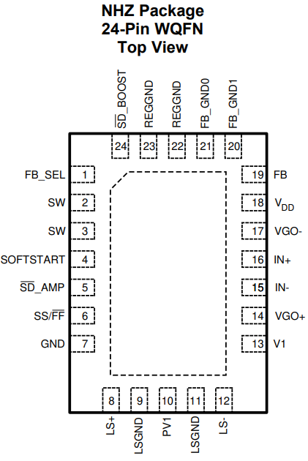
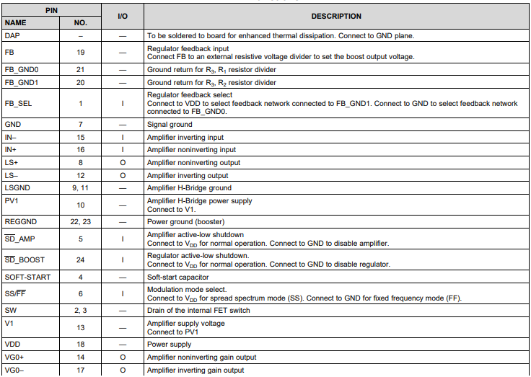

The LM48511 has 3 Vdd operating ranges: 3V, 3.6V, and 5V. The current board design only offers 6V, 5V, and 3.3V supplies. The 5V supply will be used to power this IC due to the IC’s output power at the correlated supply voltage.

The Electrical Characteristics table from the datasheet gives the following values for operation at 5V.
- R3 = 25.5 kOhm
- RLS = 4.87 kOhm
- RL = 8 Ohm (Speaker load)
- f = 1 kHz
- SS/FF = GND

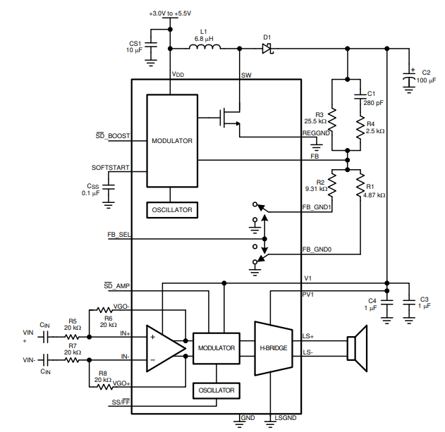

The LM48511 features 2 independent shutdown controls, SD_AMP for the Class D amplifiers, and SD_BOOST for the regulator. These inputs can be driven low to disable the corresponding parts of the IC. These pinouts do not require pulldown/pullup resistors.

FB_SEL is to be connected to GND in parallel with a 0.1uF cap connected to GND.

Add switch for SS/FF to select and deselect spread spectrum mode in testing phase. Other switches for SD_AMP and SD_BOOST can be added as shown below.
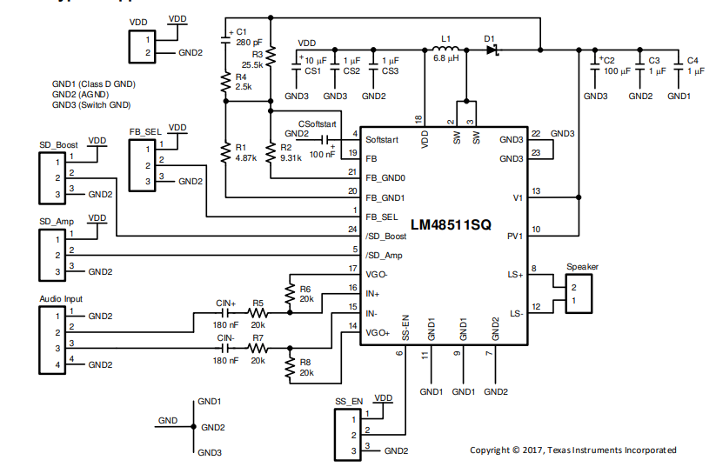
Use only multi-layer X5R and X7R ceramic capacitors.

For single ended application use a 0.18 uF capacitor and 20 kOhm resistors

A 30-V diode such as the DFLS230LH is recommended by TI. The recommended inductor is the IHLP-2525CZ-01.

Parts List
- LM48511(Audio Amp IC) https://www.mouser.com/ProductDetail/Texas-Instruments/LM48511SQX-NOPB?qs=QbsRYf82W3Hm0FRj7ooTlA%3D%3D
- DFLS230LH-7 (Diode) https://www.digikrrey.com/en/products/detail/diodes-incorporated/DFLS230LH-7/776777
- IHLP2525CZER6R8M01 (6.8 uH Inductor) https://www.digikey.com/en/products/detail/vishay-dale/IHLP2525CZER6R8M01/1220676
- CC0402KRX5R6BB184 (0.18 uF Capacitor) https://www.digikey.com/en/products/detail/yageo/CC0402KRX5R6BB184/11489798
- RC0603FR-0720KL (20 kOhm Resistor) x2 https://www.digikey.com/en/products/detail/yageo/RC0603FR-0720KL/727040
- CR0603-FX-4871ELF (4.87 kOhm Resistor) https://www.digikey.com/en/products/detail/bourns-inc/CR0603-FX-4871ELF/3784054
- RC0603FR-079K31L (9.31 kOhm Resistor) https://www.digikey.com/en/products/detail/yageo/RC0603FR-079K31L/727420
- RNCF0603BTE2K50 (2.5 kOhm Resistor) https://www.digikey.com/en/products/detail/stackpole-electronics-inc/RNCF0603BTE2K50/6262233
- C0603C104K5RACTU (100 nF Capacitor) x2 USE EXISTING CAP MODEL https://www.digikey.com/en/products/detail/kemet/C0603C104K5RACTU/1465594
- CC0603KRX7R9BB271 (270 pF Capacitor) https://www.digikey.com/en/products/detail/yageo/CC0603KRX7R9BB271/372858
- CL10A106KP8NNNC (10uF Capacitor) USE EXISTING CAP MODEL https://www.digikey.com/en/products/detail/samsung-electro-mechanics/CL10A106KP8NNNC/3886850
- CL10B105KP8NNNC (1 uF Capacitor) x4 USE EXISTING CAP MODEL https://www.digikey.com/en/products/detail/samsung-electro-mechanics/CL10B105KP8NNNC/3887604
- GRM21BR60G107ME11L (100 uF Capacitor) https://www.digikey.com/en/products/detail/murata-electronics/GRM21BR60G107ME11L/6155750
- OS102011MS2QN1 (Switch) x4 USE EXISTING CAP MODEL https://www.digikey.com/en/products/detail/c-k/OS102011MS2QN1/411602
- RC0603FR-0725K5L (25.5 kOhm Resistor) https://www.digikey.com/en/products/detail/yageo/RC0603FR-0725K5L/727088

References
Texas Instruments, "LM48511 3-W, ultra-low EMI, filterless, mono Class D audio power amplifier datasheet," LM48511, July 2007. [Online]. Available: https://www.ti.com/lit/ds/symlink/lm48511.pdf

